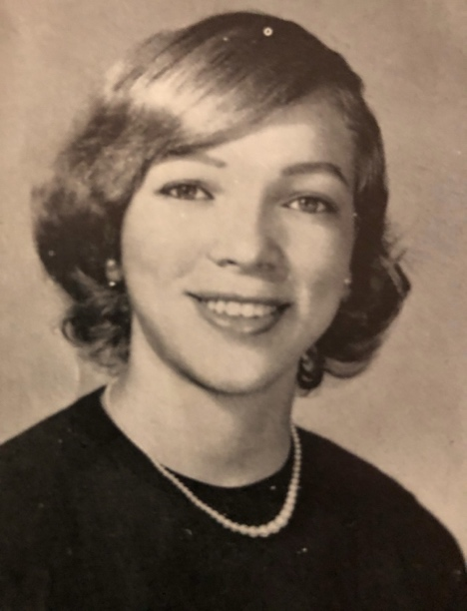

**Wilfreta Gourdine Baugh, MD**

**Scholarship**

Ms. Evelyn K. Graham

Vice President for Development

Office of Development

Hampton University

200 William R. Harvey Way

Hampton, VA  23668

Dear Ms. Graham:

I am delighted to honor Wilfreta Gourdine Baugh, MD with this contribution to her legacy scholarship at Hampton University. Enclosed you will find a check in the amount of

$___________.

Warmest Regards,